# Lab: Introduction to Bootstrap

Problems for exercises and homework for the ["JavaScript For Front-End Course @ SoftUni"](https://softuni.bg/trainings/2032/javascript-for-front-end-july-2018#lesson-8965).

Do not use any custom **CSS**, only **Bootstrap** is **required**.

## Grid System

Create a Web Page like the following:

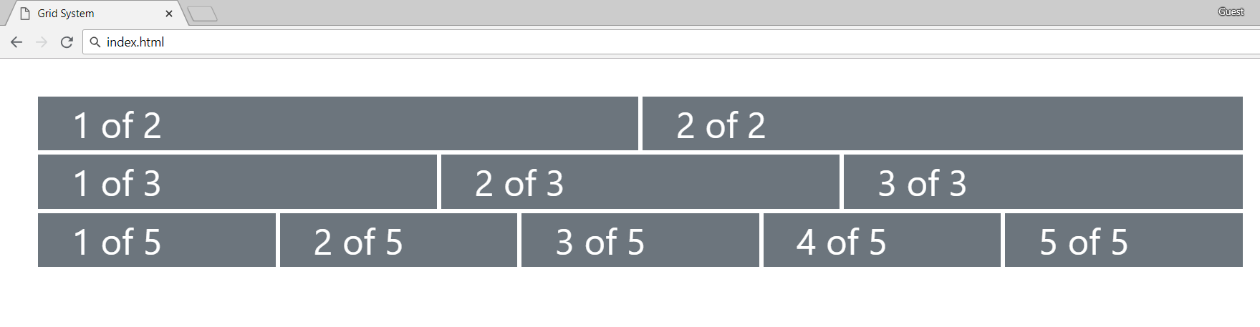

### Constraints

* Look at [Bootstrap Grid System documentation](https://getbootstrap.com/docs/4.0/layout/grid/)

### Hints

* Use class **row** for every line
* Define containers with class **col** inside every row
* Use margin (**m-3**) class for the main container
* Use **bg-secondary** color for every column
* Create your custom **CSS** file to style the borders and text color

## Navigation Bar

Create a Web Page like the following:

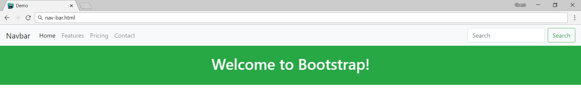

### Constraints

* Read about navigation bars at <https://getbootstrap.com/docs/4.0/components/navbar/>

### Hints

* Use class **navbar**
* Remove default paddings for the navigation (**p-0**)
* Use separate containers for navigation and welcome message

## Table

Create a Web Page like the following:

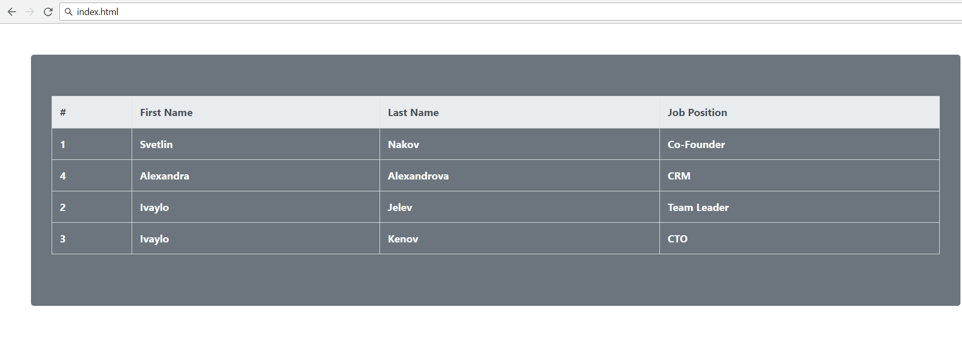

### Constraints

* Read about **tables** in **Bootstrap** at <https://getbootstrap.com/docs/4.0/content/tables/>

## Form

Create a Web Page like the following:

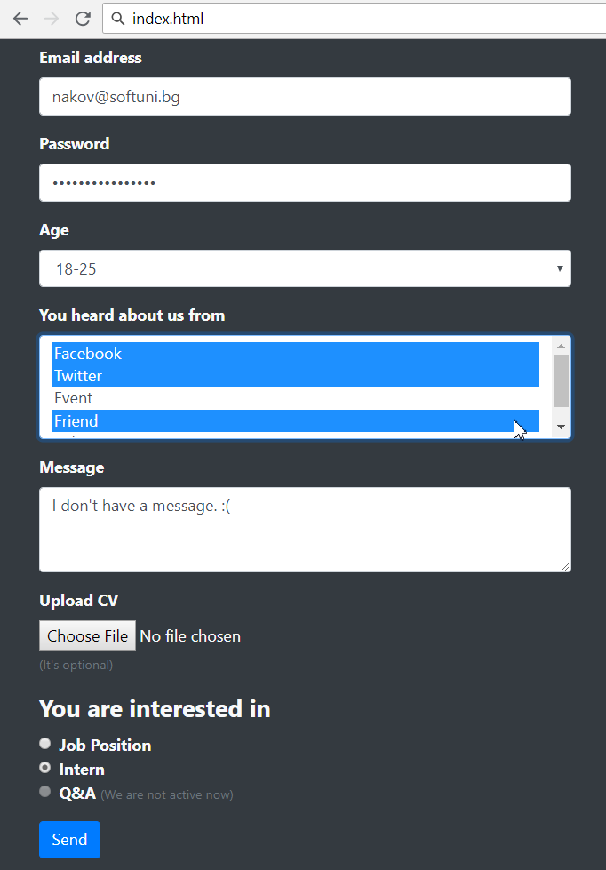

### Constraints

* Read about **tables** in **Bootstrap** at <https://getbootstrap.com/docs/4.0/content/tables/>

